Physarum Polycephalum Search Algorithm

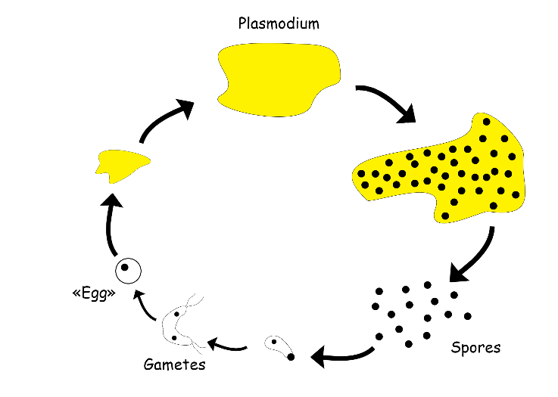

# Physarum polycephalum: An Overview

## Introduction

Physarum polycephalum, commonly known as the “many-headed slime mold,” is a single-celled, multinucleate organism belonging to the phylum Amoebozoa. Despite being a unicellular organism, it exhibits complex behaviors such as problem-solving, navigation, and memory, making it a fascinating subject of study in various scientific fields, including biology, computer science, and robotics.

# Biological Classification

###### - Domain: Eukaryota

###### - Kingdom: Protista

###### - Phylum: Amoebozoa

###### - Class: Myxomycetes

###### - Order: Physarales

###### - Family: Physaraceae

###### - Genus: Physarum

###### - Species: P. polycephalum

## Morphology and Life Cycle

Physarum polycephalum has a unique life cycle that includes several distinct stages:

1. Plasmodium Stage: In its active feeding stage, Physarum polycephalum exists as a large, visible, yellow plasmodium—a network of interconnected protoplasmic veins containing multiple nuclei. The plasmodium moves in search of food, primarily feeding on bacteria, fungal spores, and decaying organic matter. It exhibits remarkable ability to navigate complex environments and solve mazes to find the shortest path to food sources.

2. Sporulation: When environmental conditions become unfavorable (e.g., lack of food, moisture), the plasmodium undergoes a transformation into sporangia, which are fruiting bodies that contain spores. This reproductive phase allows the organism to survive harsh conditions.

3. Spore Stage: The spores, protected by resilient cell walls, are dispersed through air, water, or via animals and insects. When the spores land in a suitable environment, they germinate into either amoeboid cells or flagellated swarm cells.

4. Fusion and Growth: These cells can fuse to form a new plasmodium, restarting the cycle.

Behavioral Characteristics

Physarum polycephalum exhibits several notable behaviors that challenge the conventional understanding of intelligence:

- Problem-Solving and Navigation: The slime mold can find the shortest path through a maze to reach food, demonstrating a form of spatial memory and problem-solving ability.

- Adaptation and Learning: Studies have shown that Physarum polycephalum can adapt its behavior based on past experiences, such as learning to navigate around repellents or obstacles, indicating a primitive form of learning and memory.

- Network Optimization: The organism's plasmodium can optimize its network of veins to efficiently connect multiple food sources, akin to solving complex optimization problems. This behavior has inspired algorithms in computer science, particularly in the fields of network design and artificial intelligence.

Scientific and Practical Applications

The unique properties of Physarum polycephalum make it a model organism in various fields:

- Biological Research: It serves as a model organism for studying cell motility, differentiation, and the behavior of multinucleate cells.

- Bioinformatics and Computer Science: The slime mold's problem-solving abilities inspire the development of algorithms for optimization, robotics, and network design.

- Material Science: Physarum's ability to form resilient networks has potential applications in developing self-repairing materials and bio-inspired robotics.

Conclusion

Physarum polycephalum is more than just a slime mold; it is a window into the complexities of simple organisms and their behaviors that mimic higher forms of intelligence. Its study not only advances our understanding of biology and the evolution of intelligence but also provides innovative solutions to modern scientific and technological challenges. This remarkable organism continues to be a source of inspiration and curiosity across multiple disciplines.